Project Design Phase-II
Data Flow Diagram & User Stories

Date | 17 February 2026
Team ID | LTVIP2026TMIDS66452
Project Name | ResolveNow: Your Platform for Online Complaints
Maximum Marks | 4 Marks

Data Flow Diagrams:
A Data Flow Diagram (DFD) is a traditional visual representation of the information flows within the ResolveNow system. A neat and clear DFD can depict the right amount of the system requirement graphically, illustrating how a user's complaint enters the platform and how resolution data leaves the system. It shows what changes the information, such as an agent updating a ticket status, and where data is stored, specifically within the MongoDB database.

Example: (Simplified)

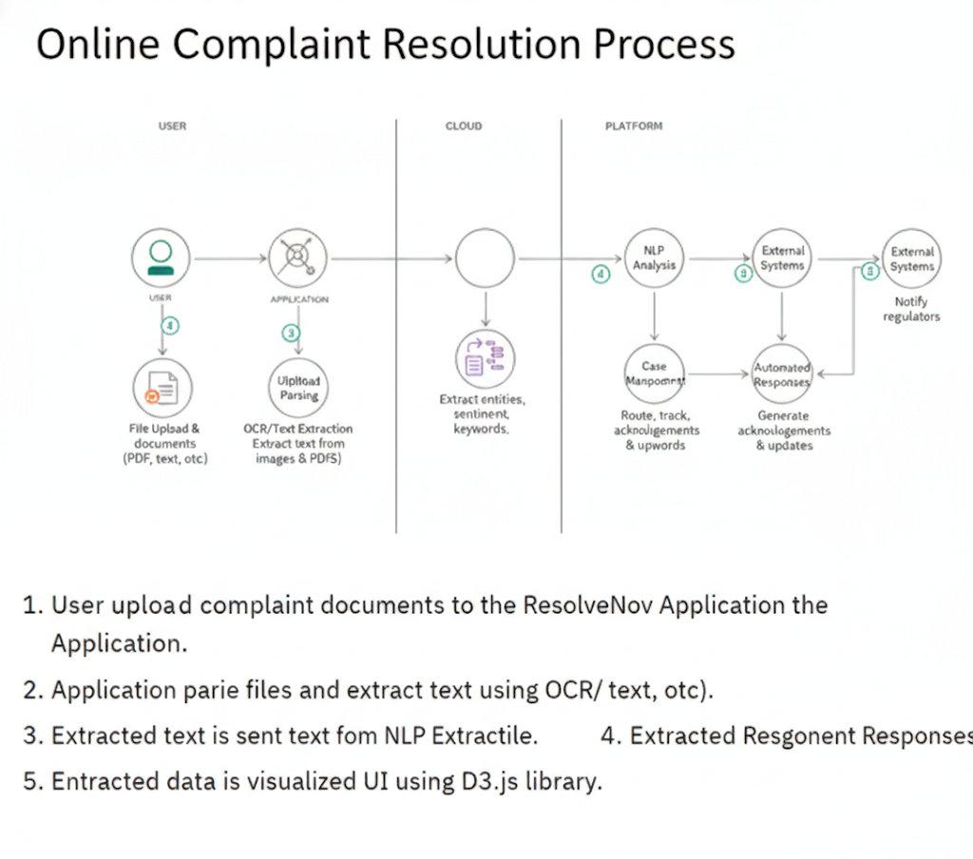

User Stories
Use the below template to list all the user stories for the product.
User Type | Functional Requirement (Epic) | User Story Number | User Story / Task | Acceptance criteria | Priority | Release
Customer (Web/Mobile) | Registration | USN-1 | As a user, I can register for the application by entering my email, password, and confirming my password. | I can access my account / dashboard | High | Sprint-1
Customer (Web/Mobile) | Intelligent Routing | USN-2 | As a user, I will receive confirmation email once I have registered for the application | I can receive confirmation email & click confirm | High | Sprint-1
Customer (Web/Mobile) | User Management | USN-3 | As a user, I can register for the application through Facebook | I can register & access the dashboard with Facebook Login | Low | Sprint-2
Customer Care Executive (Agent) | Communication | USN-4 | As a user, I can register for the application through Gmail | The system correctly assigns the ticket to the selected agent/department. | Medium | Sprint-1
Customer Care Executive (Agent) | Login | USN-5 | As a user, I can log into the application by entering email & password | Dashboard displays accurate statistics pulled from the MongoDB database. | High | Sprint-1
Administrator | Dashboard
Administrator
Administrator
Administrator

